**OFFICIAL COORDINATION REQUEST FOR**

**NON-ROUTINE OPERATIONS AND MAINTENANCE**

**COORDINATION TITLE-** **Proposed Use of Lookout Point Reservoir Water**

**COORDINATION DATE- 12 May 2023**

**PROJECT- Lookout Point Landslide Geotech Investigation**

**RESPONSE DATE- 26 May 2023**

**Description of the problem -** Multiple historic landslide deposits have occurred along Oregon State Highway 58, upstream of the Lookout Point (LOP) Dam on the south bank of the LOP Reservoir (Middle Fork Willamette River SE of Eugene-Springfield) and are the impetus for the subject investigation. USACE Portland District is currently evaluating how proposed changes in reservoir operations (deeper, longer drawdown) could affect the stability of known landslide deposits on the south bank of the reservoir. The project encompasses drilling explorations (x4), soil sampling, and installation of in-place inclinometers and piezometers. Proponent requests use of ~2000-gals water from LOP reservoir to assist with Geotech study drilling/boring ops.

**Type of outage required-** None

**Impact on facility operation-** None, no impacts to LOP dam or Reservoir Operations

**Dates of impacts/repairs-** mid-June 23 drilling operationsscheduled to begin

**Length of time for repairs-** 1-2 weeks total for upland drilling boring ops; reservoir water usage expected to be a maximum of 2, one-hour events at each of 2 drilling sites, “a small pump to pull 2,000 gallons from the reservoir into the truck…This operation would be done in less than 1-hr”

**Analysis of potential impacts to fish-**

1. De minimus impacts to fish due to:
   1. Limited timing of withdrawal event, a maximum of an ~ 1hr event at each of 2 drilling sites.
   2. Contractor required usage of pump intake screens sized to prevent/limit juvenile fish uptake per NMFS criteria (see 8.4.3 and 8.5 of the NMFS design criteria: <https://www.fisheries.noaa.gov/resource/document/anadromous-salmonid-passage-facility-design-manual>).
   3. Contractor can only withdraw water between 1000 and 1600 local time and the pump intake must be no deeper than 3ft below the surface and as far offshore as practicable.
   4. Contractor will be directed to ensure water intake hose is not disturbing any soil, (i.e., use floating intake pump or similar device).
   5. Contractor directed to capture/remove all Investigation Derived Waste (IDW) for proper offsite disposal to prevent any discharge to adjacent water bodies.
2. Estimated exposure to impact by species and age class (i.e., number or percentage of run exposed to an impact by the action);

Dependent on availability of returning adult Spring Chinook, marked, hatchery Spring Chinook are outplanted above Lookout Point and Hills Creek reservoirs as part of USACE mitigation efforts. In 2022 a total of 1,142 adult Spring Chinook were outplanted above Lookout Point and Hills Creek, representing 2.9% of the total 38,629 fish for the listed Upper Willamette Spring Chinook Evolutionary Significant Unit passing above Willamette Falls in 2022.

|  |  |  |  |
| --- | --- | --- | --- |
| *Marked ChS in North Fork Middle Fork* | | | |
| Date | Female | Male | Jack |
| July | 248 | 279 | 17 |
| August | 64 | 68 | 4 |
| Year To Date | 312 | 347 | 21 |

Table 1. Total Outplanting of Spring Chinook in the North Fork Middle Fork above Lookout Point in 2022.

|  |  |  |  |
| --- | --- | --- | --- |
| *Marked ChS Above Hills Creek* | | | |
| Date | Female | Male | Jack |
| July |  |  |  |
| August | 107 | 113 | 8 |
| September | 91 | 137 | 6 |
| Year To Date | 198 | 250 | 14 |

Table 2. Total outplanting of Spring Chinook adults above Hills Creek in 2022.

1. Type of impact by species and age class (increased delay, exposure to predation, exposure to a route of higher injury/mortality rate, exposure to higher TDG, etc.):

Adult outplants in 2021 and 2022 above Lookout Point did not begin until July at the earliest. Thus, the planned operation for June 2023 is expected to have no impact on adult Spring Chinook.

Chinook juveniles typically enter Lookout Point reservoir in late winter and early spring as fry and small parr (35mm – 55mm). These fish will rear in near shore shallows until late May and early June when they begin to occupy more pelagic offshore habitats (Monzyk et al. 2012; 2014).

By July most fish in Lookout Point are found in deeper water (see figure 1 below Monzyk et al. 2014). This is also consistent with observations made in Detroit reservoir where the mean of the median hourly depths of Chinook salmon ranged from 5.2 to 43.9ft and were deeper during the day than during the night. Mean fish depth in spring was 24ft during daylight hours (Beeman and Adams 2015).

This offshore movement is likely due to the rapid growth of the Chinook juveniles, along with the surface waters becoming much warmer. By June 15th the surface temps are typically approaching 18.4°C, see table 3.

|  |  |  |
| --- | --- | --- |
| **LOP Reservoir Water Temp (degrees C) at 0.5 feet** | | |
| **Year** | **June 1000-1600 avg** | **July 1000-1600 avg** |
| 2016 | 19.09 | 21.2 |
| 2017 | 17.46 | 21.27 |
| 2018 | 18.16 | 22.03 |
| 2019 | 18.98 | 21.38 |
| 2020 | 18.27 | 21.31 |
| **Avg** | **18.392** | **21.44** |

Table 3. The average reservoir temperature of Lookout Point in June and July from 2016 to 2020.

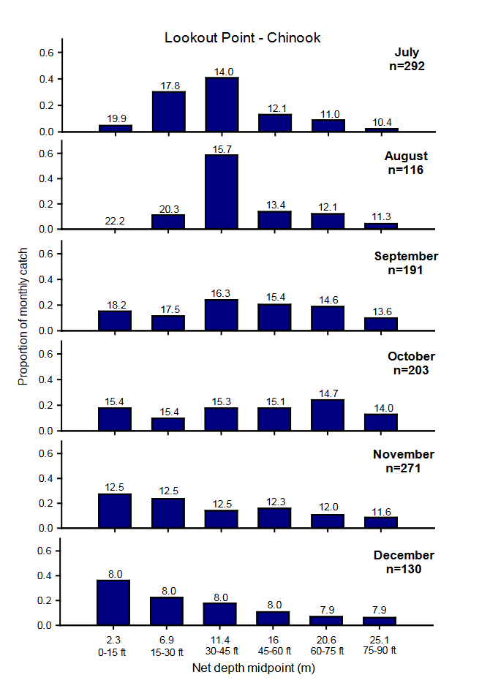

Figure 1. Proportion of juvenile Chinook salmon caught at specific depth intervals in Lookout Point Reservoir from July to December, 2012. Numbers on top of bars are mean temperatures at depth interval calculated from USACE thermistors located in the reservoir forebay (reproduced from Monzyk et. Al, 2014).

In the fall/winter of 2022 and 2023 both Lookout Point and Hills Creek were drawn down to at or below the Water Control Curve. These drawdowns likely helped facilitate the passage of both yearling and sub-yearling Spring Chinook below the projects further reducing the risk of exposure.

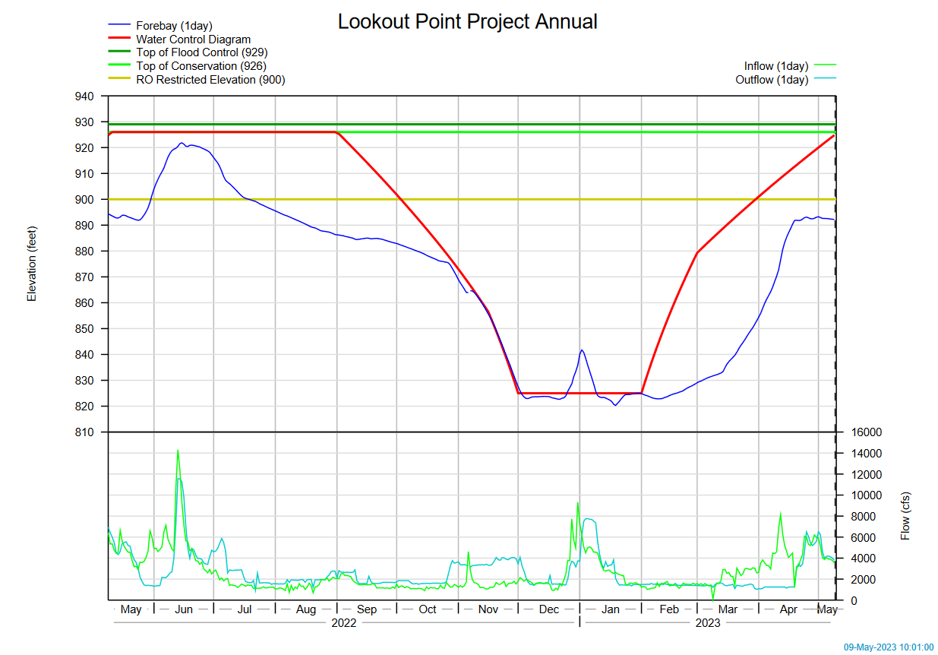

Fig 2. The annual forebay level for Lookout Point from May 2022 to May 2023.

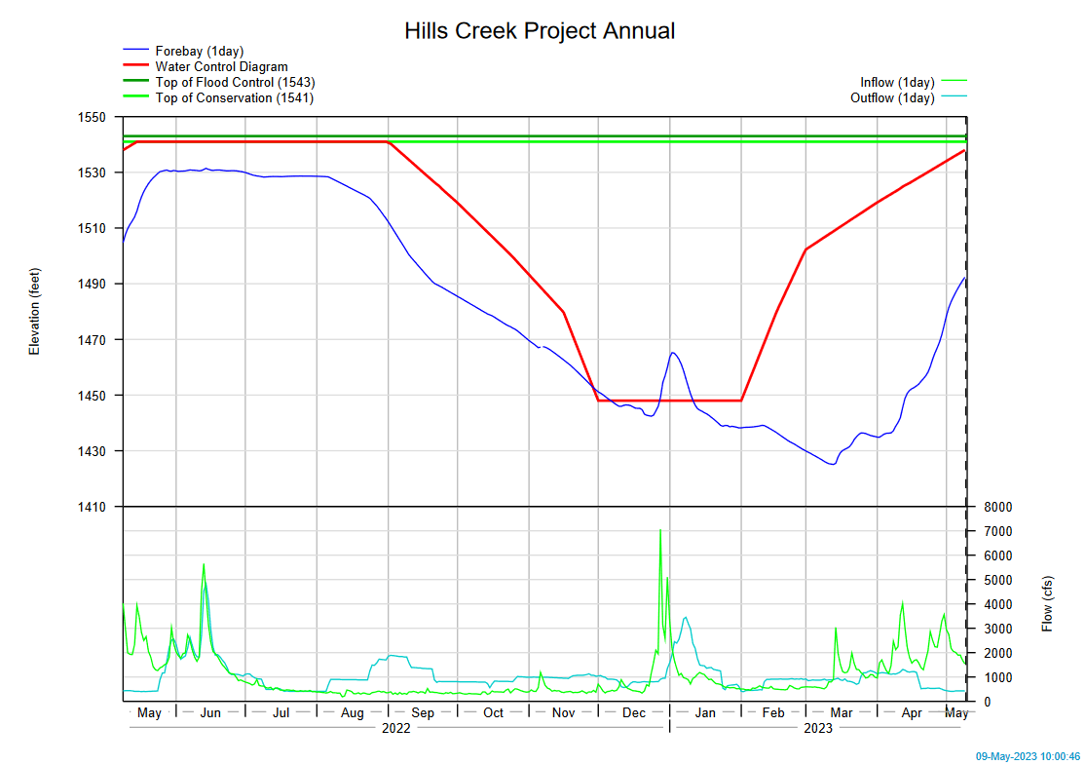

Fig 3. The annual forebay level for Hills Creek from May 2022 to May 2023.

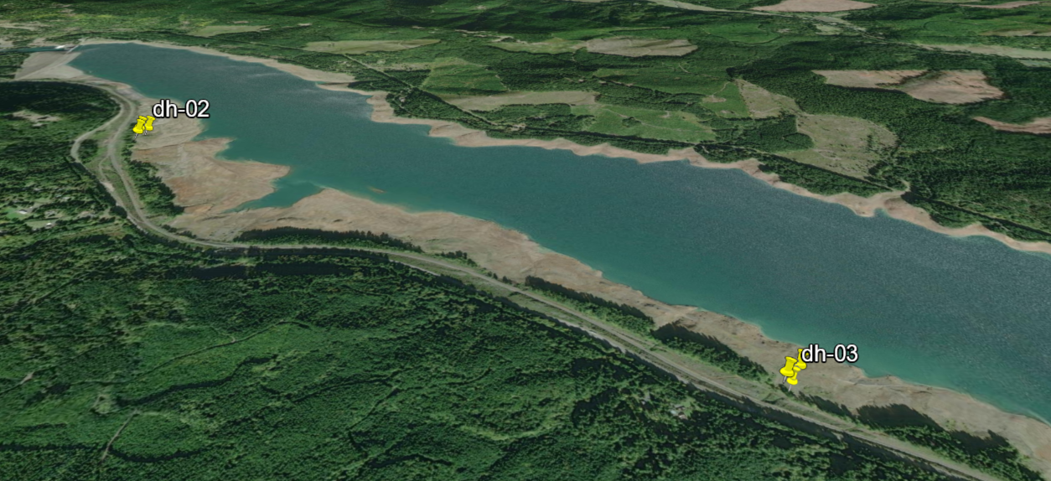

Fig 4. Lookout Point boring site #1 in the upper left and boaring site #2 in the lower right along Lookout Point Reservoir. Lookout Point Dam is located in the far upper left.

**Summary statement** – expected impacts on:

Juvenile Chinook: Minimal, due to the observed distribution of fish in the reservoir, surface water being warm, there is a low likely hood of any fish presence during pumping. Additionally the drawdown of Lookout Point and Hills Creek, most juvenile salmonids are expected to have passed projects prior to the operation.Requiring the contractor to only pump during the day and no deeper thant 3ft from the surface will further reduce the risk of exposure. Lastly, even if juveniles were present the use of NMFS criteria intake screens will greatly reduce the risk of injury and mortality from impingement and entrainment.

Adult Chinook: Very minimal, based on historical outplanting schedules and release locations well above the pumping station, no adult Spring Chinook are expected to be present at the time of the operation.

**Comments from agencies:**

**Final coordination results:**

Please email or call with questions or concerns.

Thank you,

**J Barry Moncrief, Portland District Env Resource Specialist**

Env Resources Branch

Phone: 503-808-5101

Email: [james.b.moncrief@usace.army.mil](mailto:james.b.moncrief@usace.army.mil)

David Griffith

Endangered Species Act Coordinator

USACE Portland District

(503) 808-4773

Email: [David.W.Griffith@usace.army.mil](mailto:David.W.Griffith@usace.army.mil)

Steven Sachs

Fish and Wildlife Field Biologist

Fisheries Field Unit

USACE Portland District

(541) 619-7010

Email: [steven.a.sachs@usace.army.mil](mailto:steven.a.sachs@usace.army.mil)

References:

Beeman, JW, and NS Adams. 2015. “In-Reservoir Behavior, Dam Passage, and Downstream Migration of Juvenile Chinook Salmon and Juvenile Steelhead from Detroit Reservoir and Dam to Portland, Oregon, February 2013–February 2014.” Open-File Report. Open-File Report.

Monzyk, Fred R, Jeremy D. Romer, Ryan Emig, and Thomas Friesen. 2012. “Life-History Characteristics of Juvenile Spring Chinook Salmon Rearing in Willamette Valley Reservoirs,”

Monzyk, Fred R, Jeremy D. Romer, Ryan Emig, and Thomas A Friesen. 2014. “Life-History Characteristics of Juvenile Spring Chinook Salmon Rearing in Willamette Valley Reservoirs.” *Annual Report of Oregon Department of Fish and Wildlife (ODFW) to US Army Corps of Engineers, Portland, Oregon.*